24th July 2018

**YOKOHAMA basks at the Silverstone Classic**

* YOKOHAMA completes its debut Silverstone Classic as the Official Tyre Partner
* Crowds of more than 100,000 flock to the world’s biggest classic motor racing festival
* YOKOHAMA presents a host of family entertainment and stunning road and race cars

Premium tyre manufacturer YOKOHAMA, basked in glorious sunshine at this weekend’s Silverstone Classic, presenting families and motor racing fans with a host of entertainment and fun-filled activities.

One of the key attractions during the festival was the YOKOHAMA Chelsea Skills Zone, which gave kids free football coaching sessions courtesy of Chelsea FC. Hundreds of children participated in the sessions which included a host of giveaways and prizes, such as a signed Chelsea FC shirt and football.

Naturally cars both old and new were the main attraction of the festival and a rare and pristine Aston Martin DB1 earned Allan Southward the much sought-after YOKOHAMA Club Car of the Show Award. YOKOHAMA itself presented a range of cars which reflected its diverse road and motorsport credentials including the 1988/9 BMW M3 raced by Alan Minshaw in the British Touring Car Championship through to the Hyundai i30 N TCR currently being run by Lewis Kent in the inaugural TCR UK series. Equally crowds of visitors showed their admiration for two David Brown Automotive cars which also took pride of place on the YOKOHAMA stand as well as the Supercar Legends display presented by YOKOHAMA which showcased a host of exotic modern and historic supercars.

“Wow! What an absolutely fantastic event,” enthused David Seward, managing director of Yokohama HPT. “It’s been a real pleasure to have met so many knowledgeable and passionate motoring and motor racing fans this weekend. The range and quality of cars on display was quite remarkable and the racing action was truly magnificent. We’re already looking forward to next year’s event!”

On track, the winner of the YOKOHAMA Trophy for FIA Masters Historic Sports Cars was Oliver Bryant who piloted his Lola T70 Mk3B to a thrilling victory in front of packed grandstand crowds. Bryant was presented with his trophy by Mr Omae from YOKOHAMA in Japan.

As the Official Tyre Partner of the Silverstone Classic, YOKOHAMA used the event to preview its forthcoming range of hobby tyres which are manufactured to modern standards but are ideally suited to classic cars. Indeed, a rare 1989 Porsche 911 was on show fitted with the latest YOKOHAMA A008P tyre. In addition to its tyre previews, YOKOHAMA also used the event to mark its 30th anniversary in the UK, with the company’s staff and their families joining crowds of over 100,000 to enjoy the action and other entertainment such as live music from Soul II Soul and UB40.

Commenting on the weekend, Nick Wigley, the event’s CEO said: “We were delighted to welcome YOKOHAMA to our family of event partners this year and it was brilliant to see how quickly they became part of the fabric of the event with some great new initiatives. The YOKOHAMA Chelsea Skills Zone was packed with kids improving their football skills all over the weekend. It was an incredible three days with a full programme of activity on-track and off it and so many happy, smiling faces. We’re already on countdown to next year’s event!”

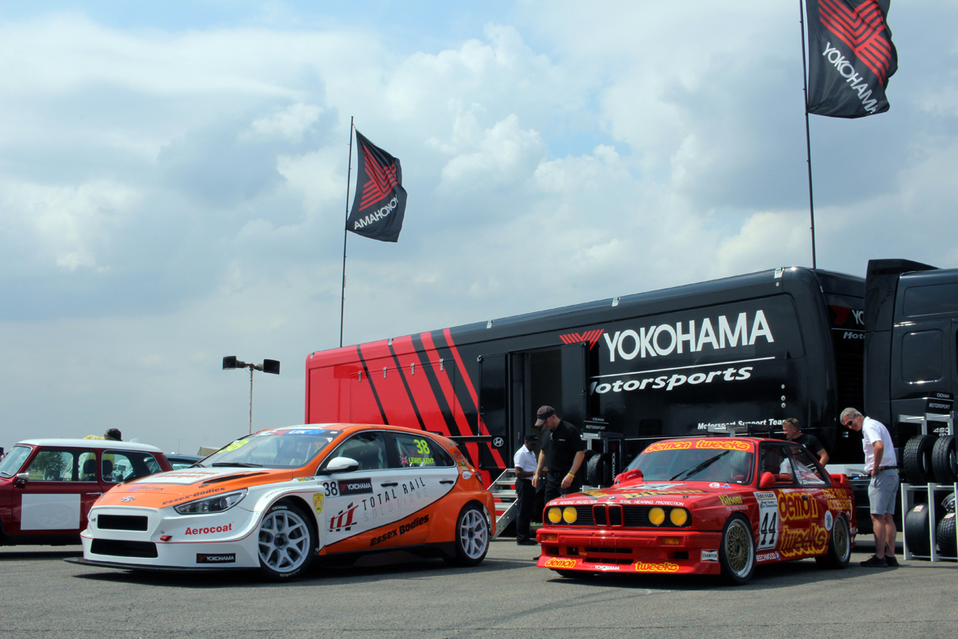

*YOKOHAMA Silverstone Classic.*

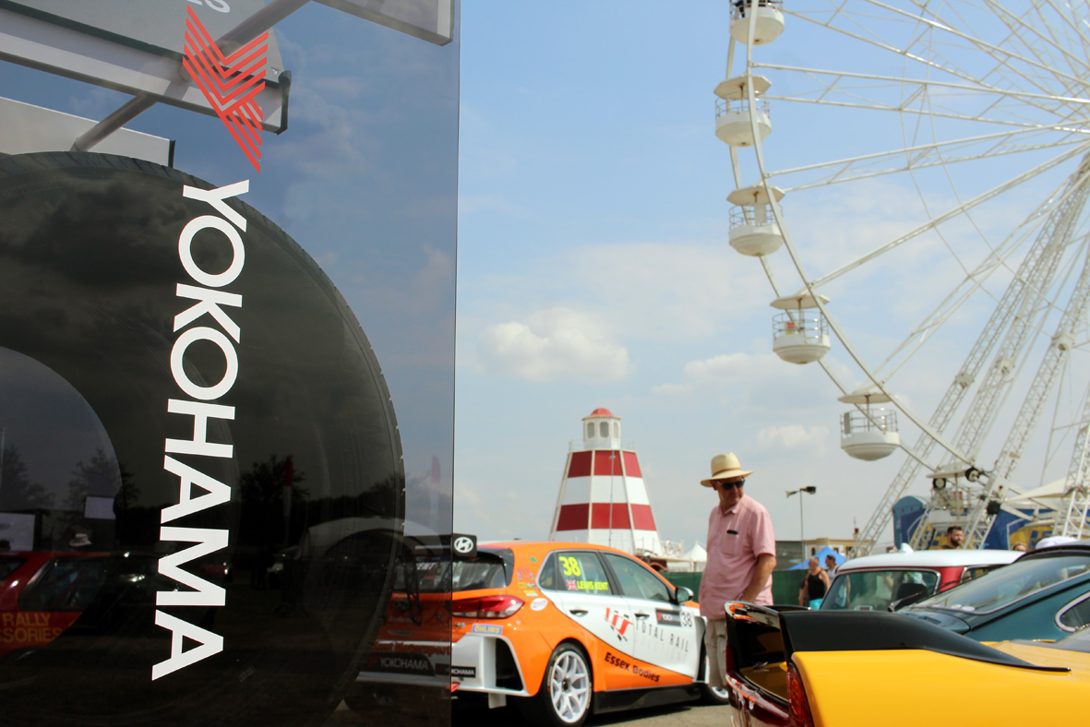

*YOKOHAMA Silverstone Classic*

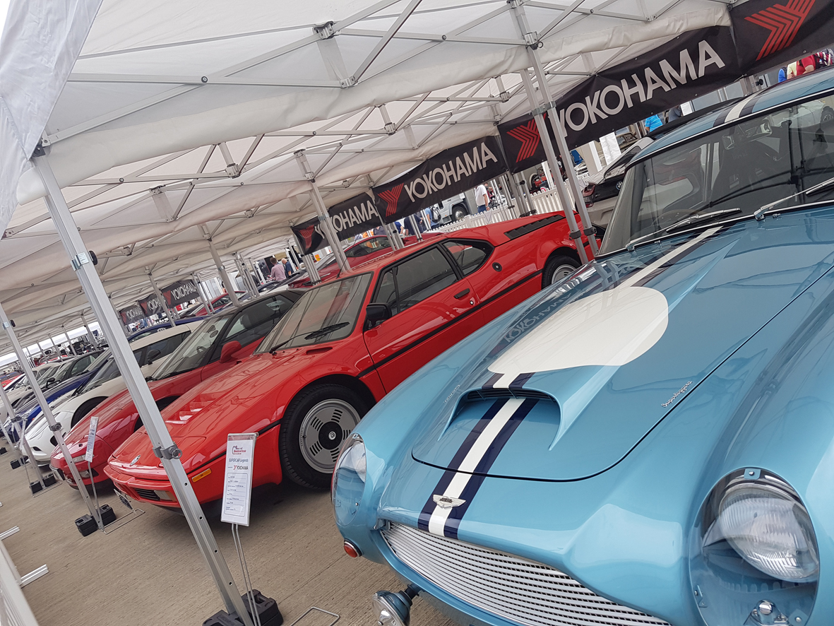

*YOKOHAMA Super Paddock*

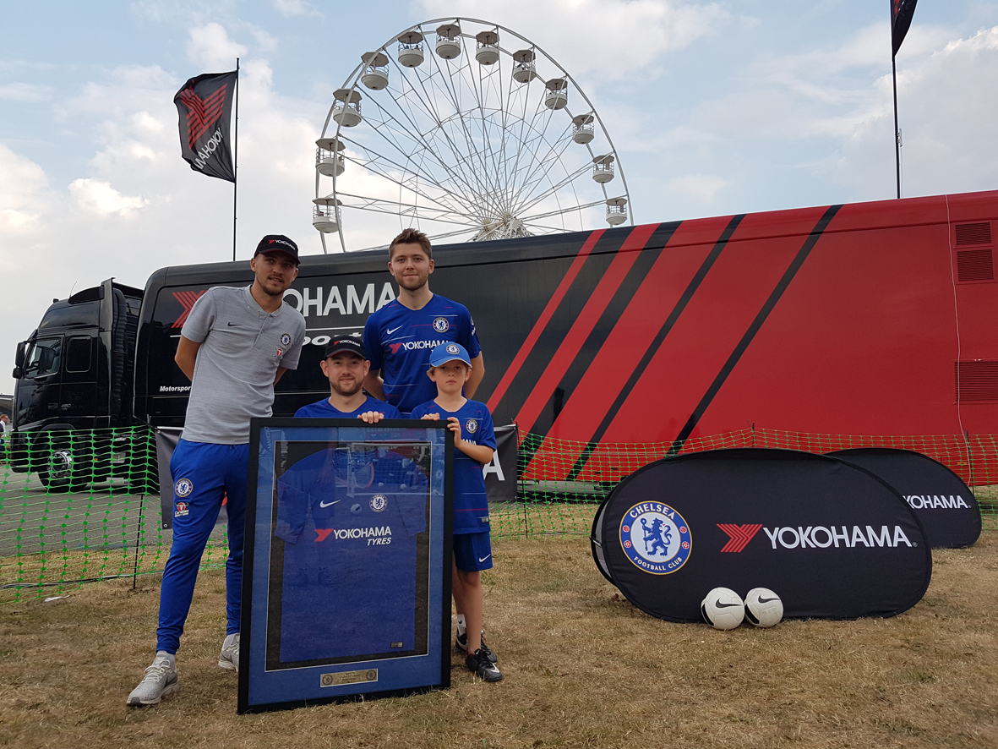

*YOKOHAMA Chelsea Skills Zone*

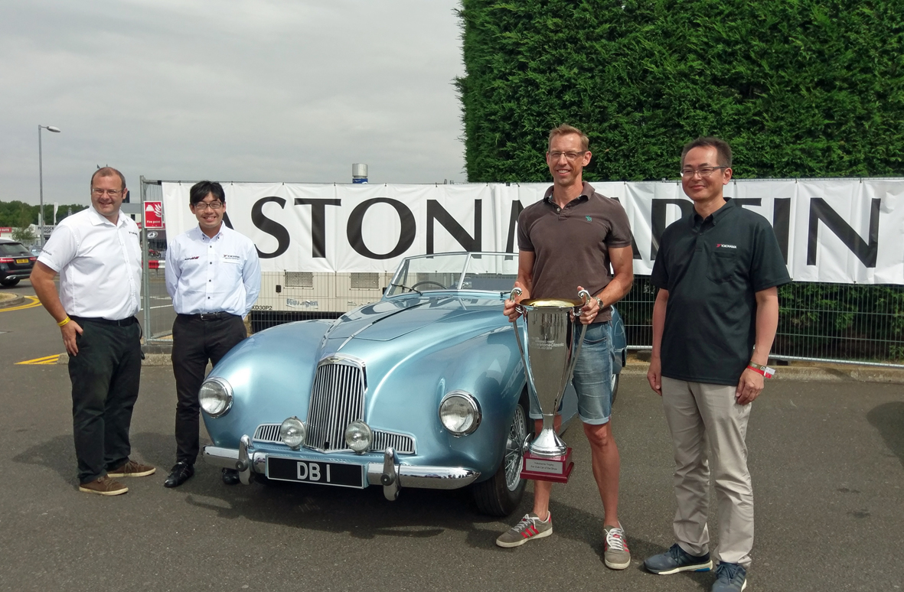

*Car of the Show Award*